Figures:

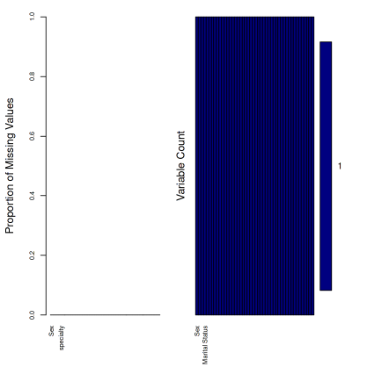

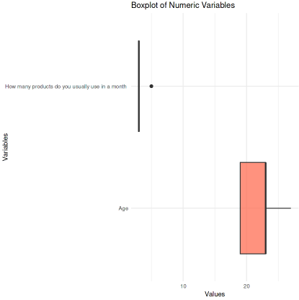

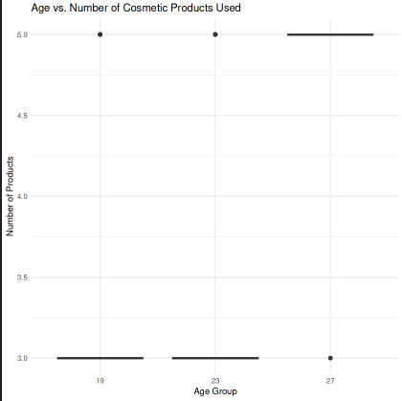

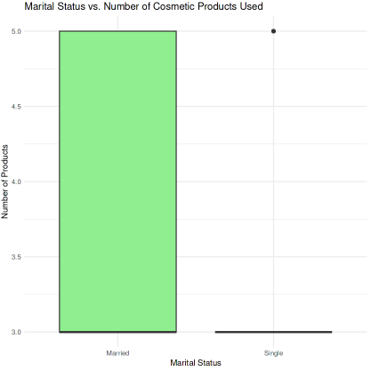

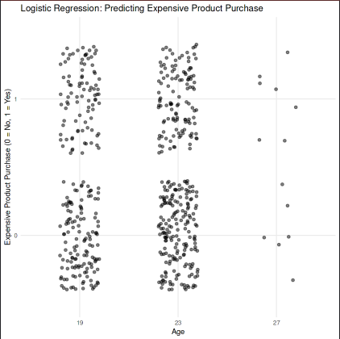

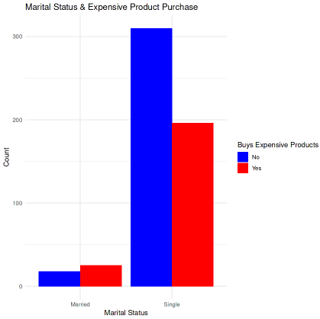

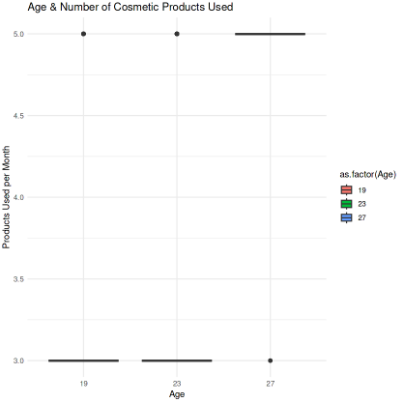

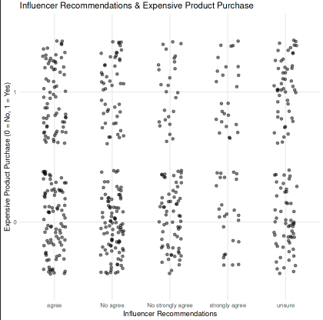

Tables:

Table 1. Fisher's Exact Test Results

|  |  |  |  |  |  |
| --- | --- | --- | --- | --- | --- |
| Comparison | Statistical Test | p-value | Odds Ratio | Statistical Significance | Conclusion |
| Marital Status vs. Cosmetic Usage | Fisher's Exact Test | 0.5598 | 1.2626 | Not Significant | Marital status does not have a statistically significant effect on cosmetic usage. |
| Education Level vs. Cosmetic Usage | Fisher's Exact Test | 1.0000 | ∞ (Infinity) | Not Significant | Education level does not influence cosmetic usage. |
| Nationality vs. Buying Behavior | Fisher's Exact Test | 0.0765 | ∞ (Infinity) | Not Significant | Nationality does not have a statistically significant impact on purchasing behavior. |
| Recommendations vs. Buying Behavior | Fisher's Exact Test | 8.167e-06 | Not Provided | Highly Significant | Recommendations significantly influence purchasing behavior. |

Table 2. ANOVA Results

|  |  |  |  |  |  |  |
| --- | --- | --- | --- | --- | --- | --- |
| Comparison | Df | Sum Sq | Mean Sq | F value | Pr(>F) | Significance |
| Age vs. Product Usage | 2 | 15.8 | 7.906 | 11.66 | 1.1e-05 | *** |
| Residuals | 546 | 370.3 | 0.678 |  |  |  |
| Marital Status vs. Product Usage | 1 | 10.5 | 10.520 | 15.32 | 0.000102 | *** |
| Residuals | 547 | 375.6 | 0.687 |  |  |  |

Table 3. Tukey HSD Test - Age vs. Number of Cosmetic Products Used

|  |  |  |  |  |
| --- | --- | --- | --- | --- |
| Age Comparison | Mean Difference | Lower Bound | Upper Bound | Adjusted p-value |
| 23 - 19 | -0.0384 | -0.2077 | 0.1309 | 0.8549 (Not Significant) |
| 27 - 19 | 1.0871 | 0.5351 | 1.6392 | 0.00001 (Significant) |
| 27 - 23 | 1.1256 | 0.5776 | 1.6735 | 0.000005 (Significant) |

Table 4. Tukey HSD Test - Marital Status vs. Number of Cosmetic Products Used

|  |  |  |  |  |
| --- | --- | --- | --- | --- |
| Marital Status Comparison | Mean Difference | Lower Bound | Upper Bound | Adjusted p-value |
| Single - Married | -0.5152 | -0.7738 | -0.2566 | 0.0001 (Significant) |

Table 5. Logistic Regression Results

|  |  |  |  |  |
| --- | --- | --- | --- | --- |
| Variable | Estimate (β) | Std. Error | z-value | p-value |
| Intercept | -12.73127 | 535.41154 | -0.024 | 0.98103 |
| Age 23 | -0.12020 | 0.18641 | -0.645 | 0.51905 |
| Age 27 | -0.17343 | 0.65158 | -0.266 | 0.79011 |
| Marital Status (Single) | -0.87514 | 0.36507 | -2.397 | 0.01652 |
| Nationality (Saudi) | 13.13392 | 535.41133 | 0.025 | 0.98043 |
| Number of Products Used Per Month | 0.02751 | 0.11188 | 0.246 | 0.80577 |
| Family & Friends Recommendation (No Agree) | -0.04218 | 0.36538 | -0.115 | 0.90809 |
| Family & Friends Recommendation (No Strongly Agree) | -0.34016 | 0.53006 | -0.642 | 0.52104 |
| Family & Friends Recommendation (Strongly Agree) | 0.23602 | 0.23952 | 0.985 | 0.32444 |
| Family & Friends Recommendation (Unsure) | 0.79028 | 0.27120 | 2.914 | 0.00357 |
| Social Media Recommendation (No Agree) | -0.35602 | 0.25248 | -1.410 | 0.15851 |
| Social Media Recommendation (No Strongly Agree) | -0.67141 | 0.30126 | -2.229 | 0.02583 |